

Practices for Secure Software Report

Table of Contents
Document Revision History 3
Client 3
Instructions 3
Developer 4
1. Algorithm Cipher 4
2. Certificate Generation 4
3. Deploy Cipher 4
4. Secure Communications 4
5. Secondary Testing 4
6. Functional Testing 4
7. Summary 4
8. Industry Standard Best Practices 4

Document Revision History

Version | Date | Author | Comments
1.0 | 06/21/2026 | Charles Roaf | Initial submission of Project Two secure software report

Client



Instructions

Submit this completed practices for secure software report. Replace the bracketed text with the relevant information. You must document your process for writing secure communications and refactoring code that complies with software security testing protocols.

- Respond to the steps outlined below and include your findings.
- Respond using your own words. You may also choose to include images or supporting materials. If you include them, make certain to insert them in all the relevant locations in the document.
- Refer to the Project Two Guidelines and Rubric for more detailed instructions about each section of the template.

Developer
Charles Roaf

Algorithm Cipher

To secure sensitive data within the application, I implemented the SHA-256 cryptographic hashing algorithm. SHA-256 is part of the Secure Hash Algorithm 2 (SHA-2) family and is widely used to ensure data integrity. Unlike encryption algorithms, hashing is a one-way process, meaning the original data cannot be reconstructed from the hash value. This makes SHA-256 well suited for checksum verification and tamper detection.
SHA-256 generates a fixed-length 256-bit hash value regardless of input size, which helps protect against collision and brute-force attacks. The large bit size significantly reduces the likelihood that two different inputs will produce the same hash value. In my implementation, SHA-256 was used to create a checksum from a unique input string, allowing verification that the data had not been altered during transmission.
Modern cryptographic practices rely on strong hashing algorithms such as SHA-256 because older algorithms like MD5 and SHA-1 have known vulnerabilities. By using SHA-256, the application follows current industry standards and provides a secure method for validating data integrity within a financial software environment.

Certificate Generation
Insert a screenshot below of the CER file.

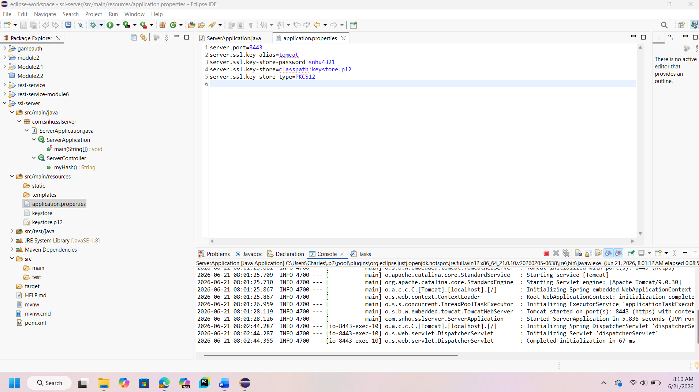

Deploy Cipher
Insert a screenshot below of the checksum verification.



Secure Communications
Insert a screenshot below of the web browser that shows a secure webpage.



Secondary Testing
Insert screenshots below of the refactored code executed without errors and the dependency-check report.

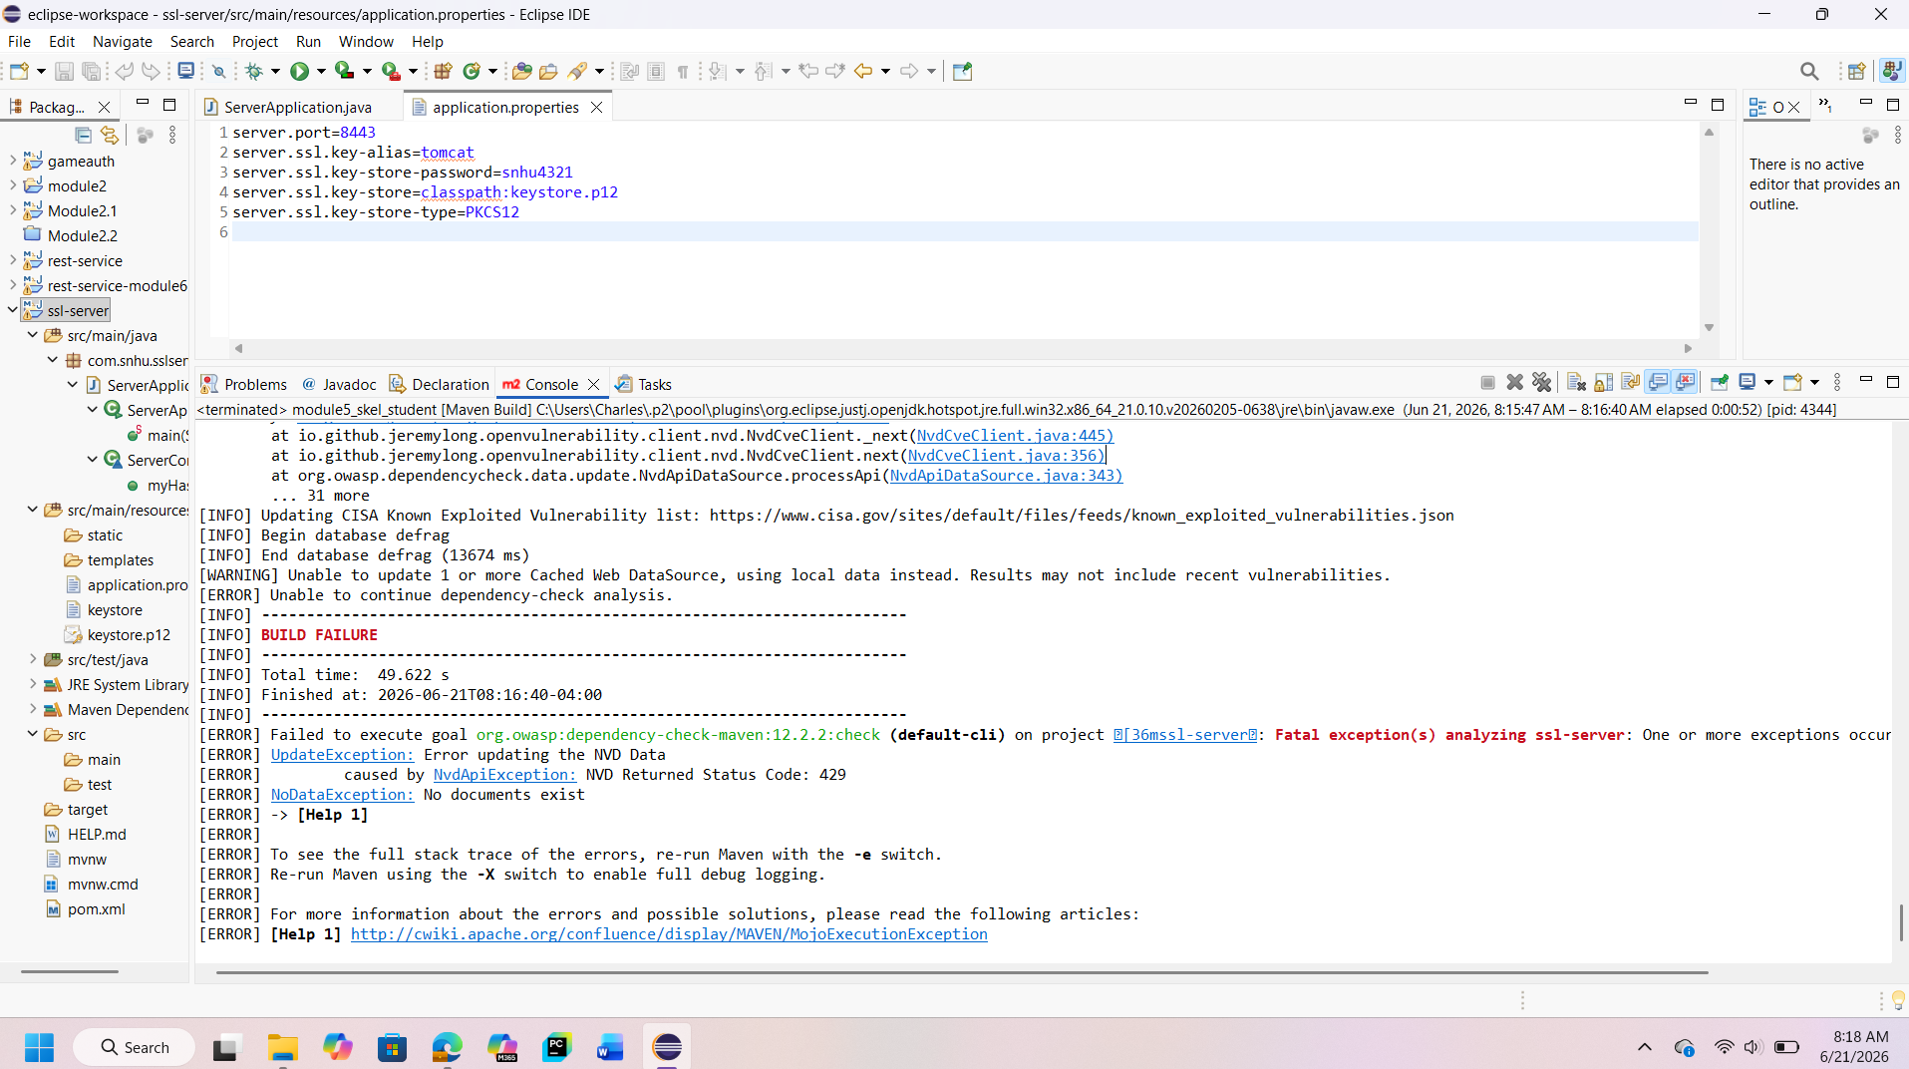

Functional Testing
Insert a screenshot below of the refactored code executed without errors.

Functional testing was conducted to ensure that the application continued to operate correctly after the security enhancements were implemented. The application itself executed successfully without runtime errors, independent of external testing tool limitations. After adding SHA-256 hashing and configuring HTTPS communication, the application started normally and remained fully functional. Testing confirmed that the /hash endpoint responded as expected when accessed through a web browser. The application correctly generated and displayed the checksum value, identified the hashing algorithm used, and returned consistent output. Additionally, the server successfully started on port 8443 using HTTPS, demonstrating that the SSL configuration did not interfere with normal application behavior. This testing verified that the security improvements did not negatively impact the system’s functionality and that the application remained stable and operational after refactoring. The results confirm that the implemented security measures were successfully integrated without introducing functional defects.

Summary

Throughout this project, I applied secure software development practices to enhance the overall security of the application. I implemented SHA-256 hashing to protect data integrity, configured SSL certificates to enable encrypted communication, and enforced HTTPS using Transport Layer Security. In addition to implementing security controls, I performed testing to validate that the application continued to function as expected. Functional testing confirmed that the application operated without errors, and secondary testing demonstrated the use of industry-standard tools to analyze third-party dependencies, even when external limitations prevented a complete scan. This project reinforced the importance of integrating security throughout the development lifecycle. By combining cryptographic techniques, secure communication protocols, and testing practices, the application achieves a stronger security posture while maintaining reliable functionality.

Industry Standard Best Practices

Industry-standard best practices were followed to ensure the application aligned with modern security expectations. Strong cryptographic algorithms such as SHA-256 were used to ensure data integrity, replacing weaker or deprecated hashing methods. Secure communication was enforced through HTTPS with TLS to protect data transmitted between the client and server. Additional best practices included the use of SSL certificates for encrypted communication, proper configuration management through application properties, and dependency analysis using OWASP Dependency-Check to identify potential risks associated with third-party libraries. These practices are consistent with recommendations from organizations such as OWASP and NIST. Following industry standards helps reduce common security vulnerabilities, protects sensitive information, and ensures that applications meet expectations for secure software development, particularly in financial and data-sensitive environments.

